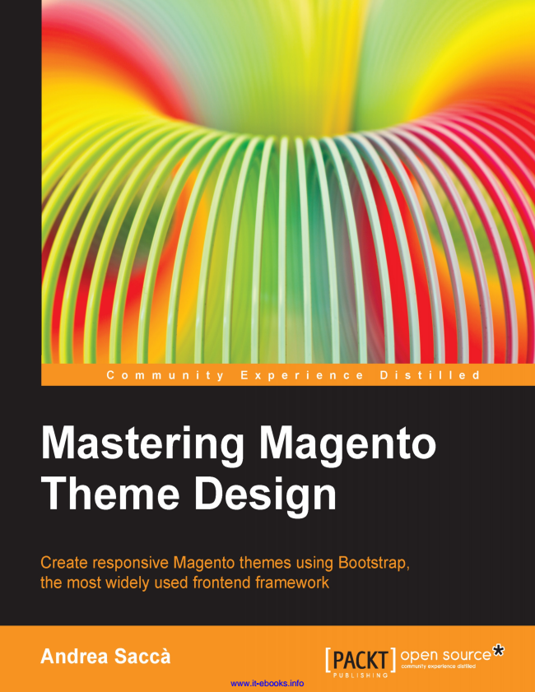

www.it-ebooks.info

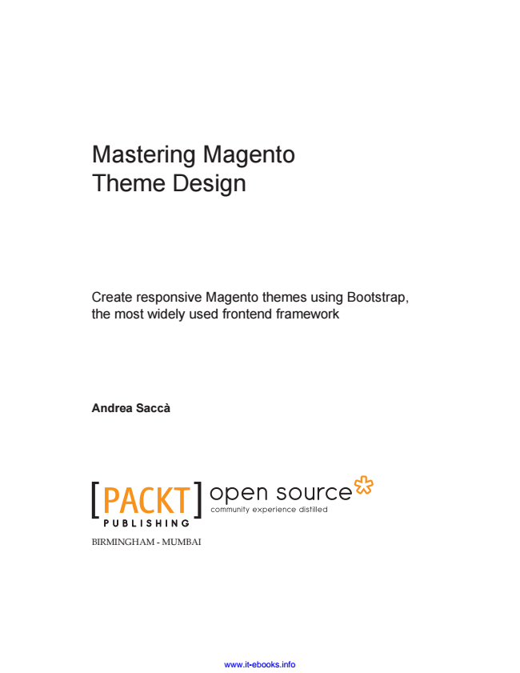

Mastering Magento Theme Design

Create responsive Magento themes using Bootstrap, the most widely used frontend framework

**Andrea Saccà**

BIRMINGHAM - MUMBAI

www.it-ebooks.info

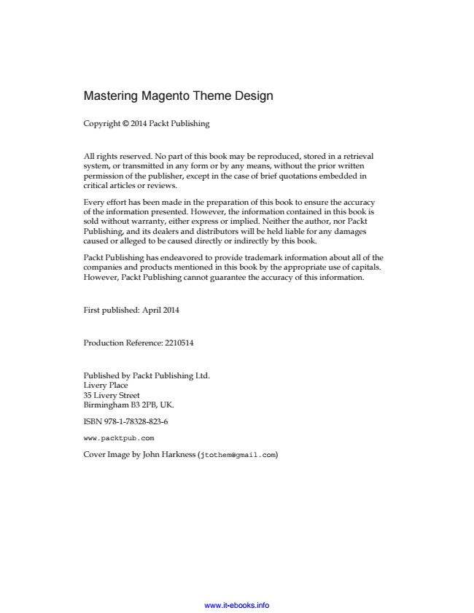

Mastering Magento Theme Design

Copyright © 2014 Packt Publishing

All rights reserved. No part of this book may be reproduced, stored in a retrieval system, or transmitted in any form or by any means, without the prior written permission of the publisher, except in the case of brief quotations embedded in critical articles or reviews.

Every effort has been made in the preparation of this book to ensure the accuracy of the information presented. However, the information contained in this book is sold without warranty, either express or implied. Neither the author, nor Packt Publishing, and its dealers and distributors will be held liable for any damages caused or alleged to be caused directly or indirectly by this book.

Packt Publishing has endeavored to provide trademark information about all of the companies and products mentioned in this book by the appropriate use of capitals. However, Packt Publishing cannot guarantee the accuracy of this information.

First published: April 2014

Production Reference: 2210514

Published by Packt Publishing Ltd. Livery Place 35 Livery Street Birmingham B3 2PB, UK.

ISBN 978-1-78328-823-6

www.packtpub.com

Cover Image by John Harkness (jtothem@gmail.com)

www.it-ebooks.info

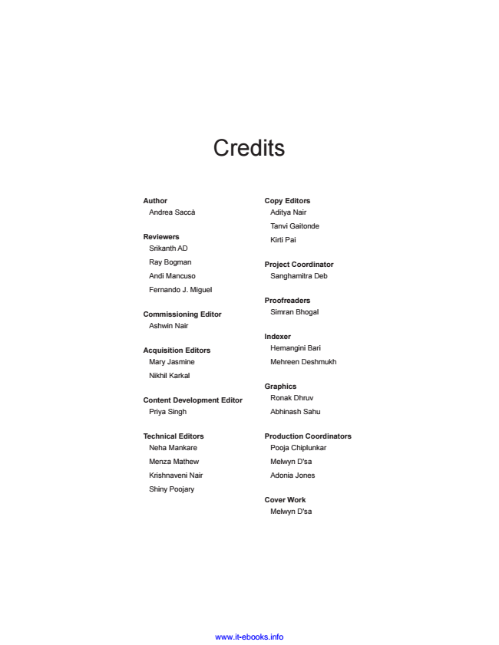

Credits

**Author**

Andrea Saccà

**Reviewers**

Srikanth AD

Ray Bogman

Andi Mancuso

Fernando J. Miguel

**Commissioning Editor**

Ashwin Nair

**Acquisition Editors**

Mary Jasmine

Nikhil Karkal

**Content Development Editor**

Priya Singh

**Technical Editors Neha Mankare**

Menza Mathew

Krishnaveni Nair

Shiny Poojary

**Copy Editors Aditya Nair**

Tanvi Gaitonde

Kirti Pai

**Project Coordinator Sanghamitra Deb**

**Proofreaders**

Simran Bhogal

**Indexer**

Hemangini Bari

Mehreen Deshmukh

**Graphics**

Ronak Dhruv

Abhinash Sahu

**Production Coordinators**

Pooja Chiplunkar

Melwyn D'sa

Adonia Jones

**Cover Work**

Melwyn D'sa

www.it-ebooks.info

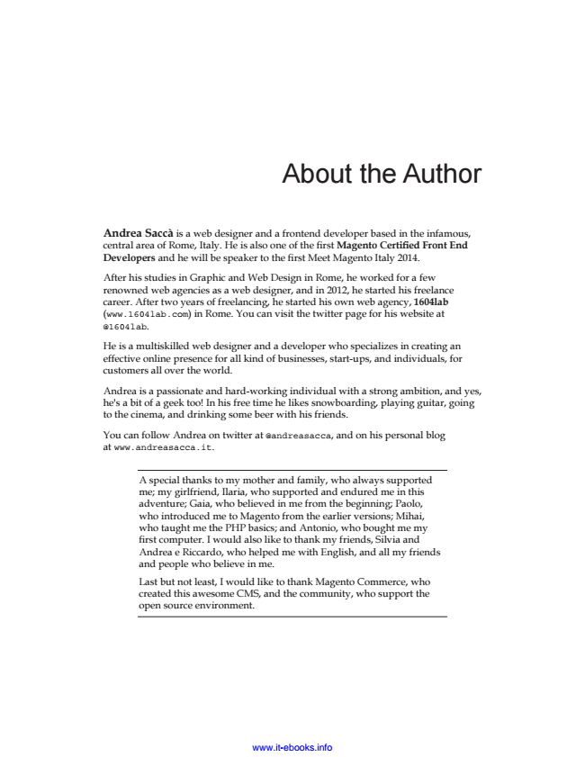

About the Author

Andrea Saccà is a web designer and a frontend developer based in the infamous, central area of Rome, Italy. He is also one of the first Magento Certified Front End Developers and he will be speaker to the first Meet Magento Italy 2014.

After his studies in Graphic and Web Design in Rome, he worked for a few renowned web agencies as a web designer, and in 2012, he started his freelance career. After two years of freelancing, he started his own web agency, 1604lab (www.1604lab.com) in Rome. You can visit the twitter page for his website at @1604lab.

He is a multiskilled web designer and a developer who specializes in creating an effective online presence for all kind of businesses, start-ups, and individuals, for customers all over the world.

Andrea is a passionate and hard-working individual with a strong ambition, and yes, he's a bit of a geek too! In his free time he likes snowboarding, playing guitar, going to the cinema, and drinking some beer with his friends.

You can follow Andrea on twitter at @andreasacca, and on his personal blog at www.andreasacca.it.

A special thanks to my mother and family, who always supported me; my girlfriend, Ilaria, who supported and endured me in this adventure; Gaia, who believed in me from the beginning; Paolo, who introduced me to Magento from the earlier versions; Mihai, who taught me the PHP basics; and Antonio, who bought me my first computer. I would also like to thank my friends, Silvia and Andrea e Riccardo, who helped me with English, and all my friends and people who believe in me.

Last but not least, I would like to thank Magento Commerce, who created this awesome CMS, and the community, who support the open source environment.

www.it-ebooks.info

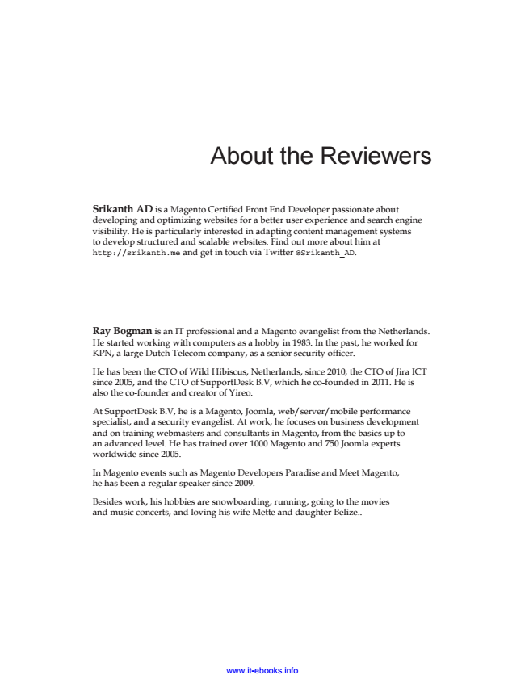

About the Reviewers

Srikanth AD is a Magento Certified Front End Developer passionate about developing and optimizing websites for a better user experience and search engine visibility. He is particularly interested in adapting content management systems to develop structured and scalable websites. Find out more about him at http://srikanth.me and get in touch via Twitter @Srikanth_AD.

Ray Bogman is an IT professional and a Magento evangelist from the Netherlands. He started working with computers as a hobby in 1983. In the past, he worked for KPN, a large Dutch Telecom company, as a senior security officer.

He has been the CTO of Wild Hibiscus, Netherlands, since 2010; the CTO of Jira ICT since 2005, and the CTO of SupportDesk B.V, which he co-founded in 2011. He is also the co-founder and creator of Yireo.

At SupportDesk B.V, he is a Magento, Joomla, web/server/mobile performance specialist, and a security evangelist. At work, he focuses on business development and on training webmasters and consultants in Magento, from the basics up to an advanced level. He has trained over 1000 Magento and 750 Joomla experts worldwide since 2005.

In Magento events such as Magento Developers Paradise and Meet Magento, he has been a regular speaker since 2009.

Besides work, his hobbies are snowboarding, running, going to the movies and music concerts, and loving his wife Mette and daughter Belize..

www.it-ebooks.info

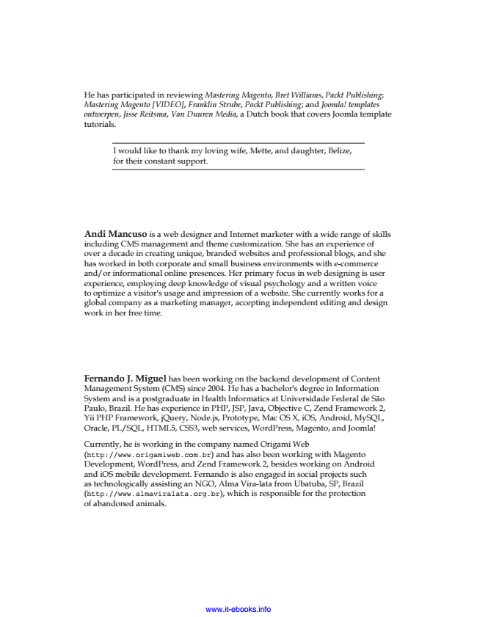

*He has participated in reviewing Mastering Magento, Bret Williams, Packt Publishing; Mastering Magento [VIDEO], Franklin Strube, Packt Publishing; and Joomla! templates ontwerpen, Jisse Reitsma, Van Duuren Media, a Dutch book that covers Joomla template tutorials.*

I would like to thank my loving wife, Mette, and daughter, Belize, for their constant support.

Andi Mancuso is a web designer and Internet marketer with a wide range of skills including CMS management and theme customization. She has an experience of over a decade in creating unique, branded websites and professional blogs, and she has worked in both corporate and small business environments with e-commerce and/or informational online presences. Her primary focus in web designing is user experience, employing deep knowledge of visual psychology and a written voice to optimize a visitor's usage and impression of a website. She currently works for a global company as a marketing manager, accepting independent editing and design work in her free time.

Fernando J. Miguel has been working on the backend development of Content Management System (CMS) since 2004. He has a bachelor's degree in Information System and is a postgraduate in Health Informatics at Universidade Federal de São Paulo, Brazil. He has experience in PHP, JSP, Java, Objective C, Zend Framework 2, Yii PHP Framework, jQuery, Node.js, Prototype, Mac OS X, iOS, Android, MySQL, Oracle, PL/SQL, HTML5, CSS3, web services, WordPress, Magento, and Joomla!

Currently, he is working in the company named Origami Web (http://www.origamiweb.com.br) and has also been working with Magento Development, WordPress, and Zend Framework 2, besides working on Android and iOS mobile development. Fernando is also engaged in social projects such as technologically assisting an NGO, Alma Vira-lata from Ubatuba, SP, Brazil (http://www.almaviralata.org.br), which is responsible for the protection of abandoned animals.

www.it-ebooks.info

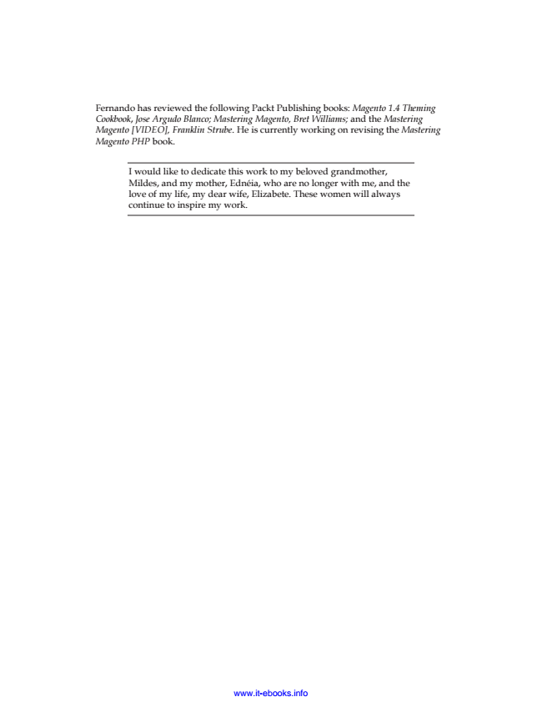

*Fernando has reviewed the following Packt Publishing books: Magento 1.4 Theming Cookbook, Jose Argudo Blanco; Mastering Magento, Bret Williams; and the Mastering Magento [VIDEO], Franklin Strube. He is currently working on revising the Mastering Magento PHP book.*

I would like to dedicate this work to my beloved grandmother, Mildes, and my mother, Ednéia, who are no longer with me, and the love of my life, my dear wife, Elizabete. These women will always continue to inspire my work.

www.it-ebooks.info

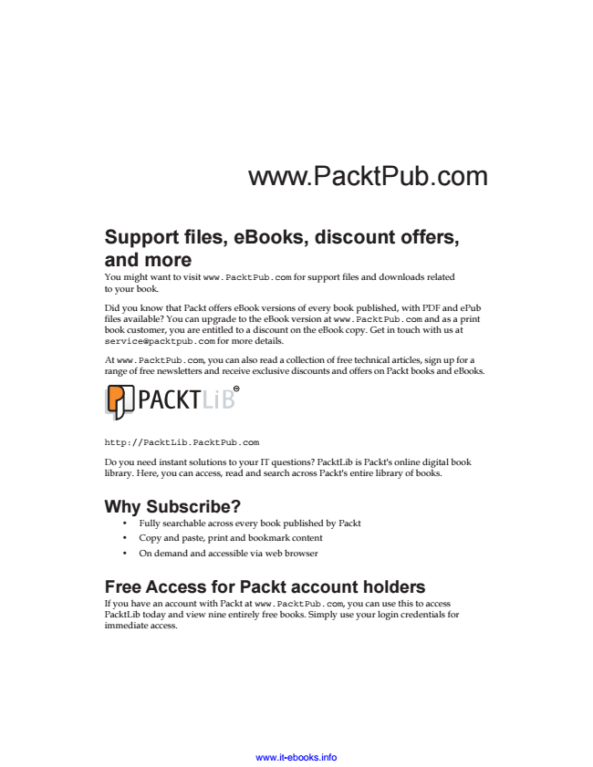

www.PacktPub.com

Support files, eBooks, discount offers, and more You might want to visit www.PacktPub.com for support files and downloads related to your book.

Did you know that Packt offers eBook versions of every book published, with PDF and ePub files available? You can upgrade to the eBook version at www.PacktPub.com and as a print book customer, you are entitled to a discount on the eBook copy. Get in touch with us at service@packtpub.com for more details.

At www.PacktPub.com, you can also read a collection of free technical articles, sign up for a range of free newsletters and receive exclusive discounts and offers on Packt books and eBooks.

TM

http://PacktLib.PacktPub.com

Do you need instant solutions to your IT questions? PacktLib is Packt's online digital book library. Here, you can access, read and search across Packt's entire library of books.

**Why Subscribe?**

• Fully searchable across every book published by Packt

• Copy and paste, print and bookmark content

• On demand and accessible via web browser

Free Access for Packt account holders If you have an account with Packt at www.PacktPub.com, you can use this to access PacktLib today and view nine entirely free books. Simply use your login credentials for immediate access.

www.it-ebooks.info

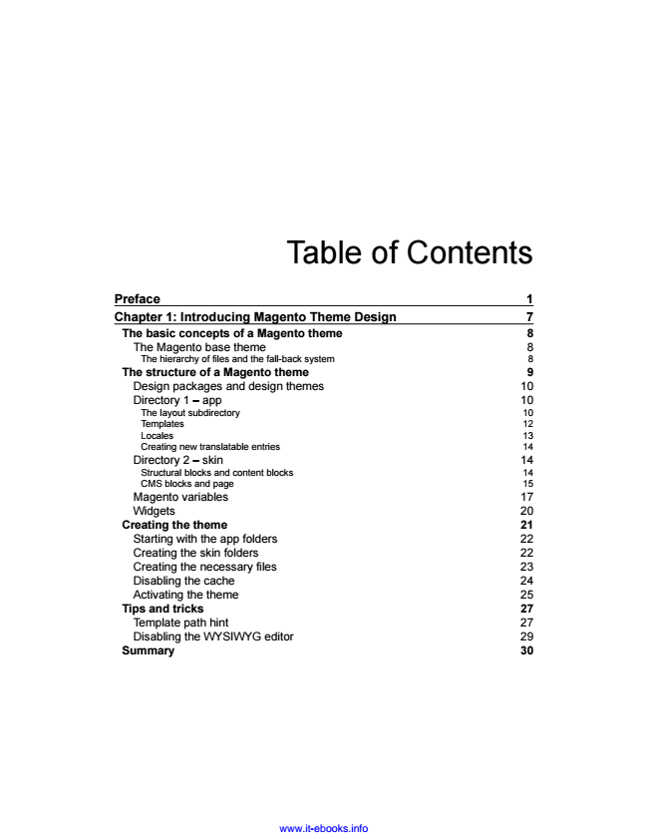

Table of Contents

Preface 1 Chapter 1: Introducing Magento Theme Design 7 The basic concepts of a Magento theme 8 The Magento base theme 8 The hierarchy of files and the fall-back system 8 The structure of a Magento theme 9 Design packages and design themes 10 Directory 1 – app 10 The layout subdirectory 10 Templates 12 Locales 13 Creating new translatable entries 14 Directory 2 – skin 14 Structural blocks and content blocks 14 CMS blocks and page 15 Magento variables 17 Widgets 20 Creating the theme 21 Starting with the app folders 22 Creating the skin folders 22 Creating the necessary files 23 Disabling the cache 24 Activating the theme 25 Tips and tricks 27 Template path hint 27 Disabling the WYSIWYG editor 29 Summary 30

www.it-ebooks.info